Virtual Learning Platform
How to Assign Yearly Professional Development by Building Administrator
The yearly PD assignment function is a quick way for a Building Admin to assign Professional Learning Modules (PLMs) and Self-Assessment Practice Profiles (SAPPs) either individually or together for the entire staff.
The Yearly PD Assignments can be found on the District Menu highlighted below:
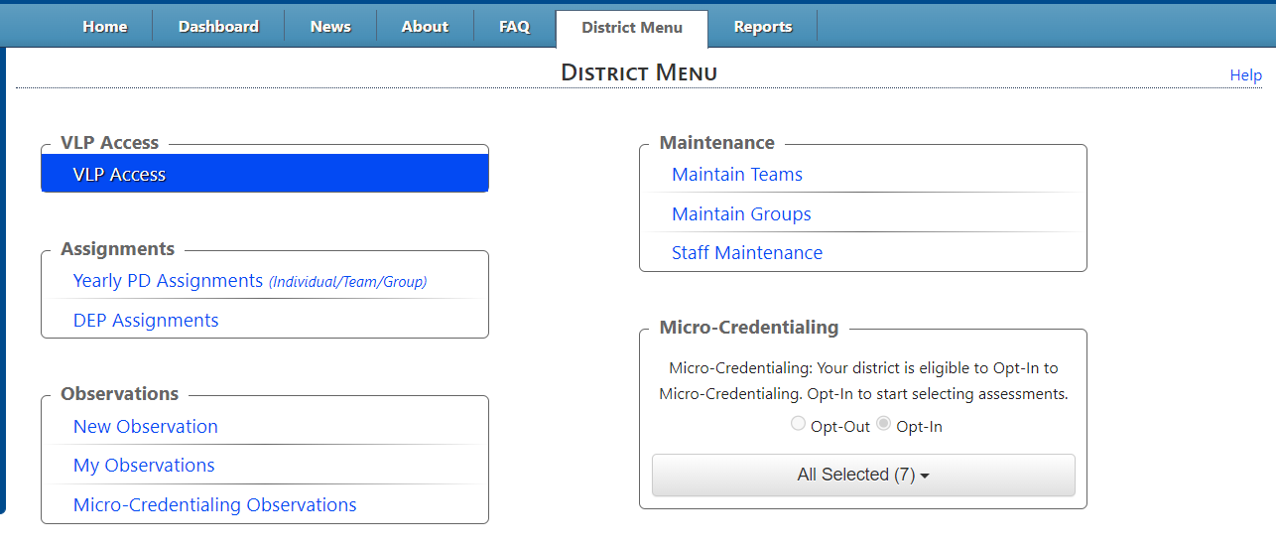Clicking the link will display the following screen 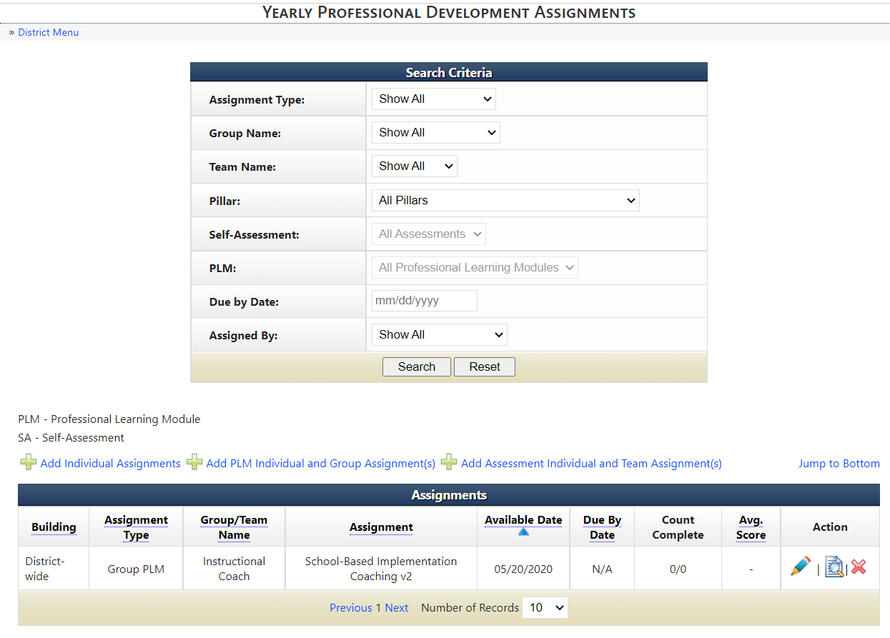
The Add Individual Assignments will create both PLM and SAPP assignments. The Add PLM Assignment will create a PLM assignment. The Add SA Assignment will create a SAPP assignment.
The first example shown below will create both PLM and SAPP assignments
Click on Add Individual Assignments as highlighted in yellow above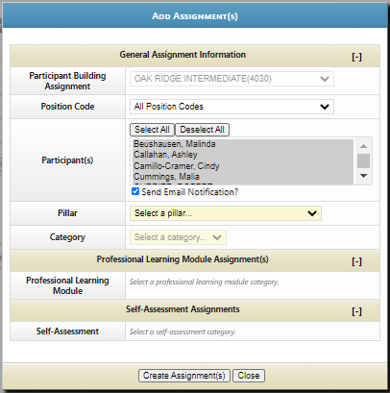
The first step is to select who will be doing the assignment. Personnel can be chosen by position code in the building. Select All or individual participants

Select who will participate in the training. Select a pillar and then a category.
Select the Professional Learning Module you want, and then the dates of the PLM window you want open.
Select the Self-Assessment you want, add assessment instructions, and complete the Initial Self-Assessment Window.
In Re-Assessments, fill in the dates of the window to take the re-assessment.
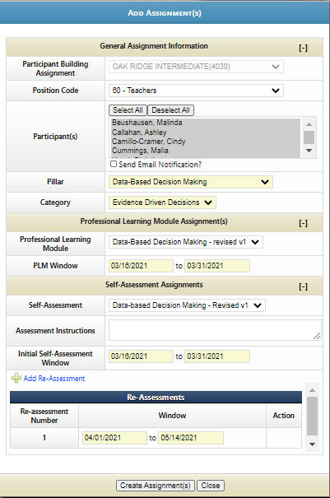

Click the Create Assignment(s) button.
A confirmation screen will show your selections.
