Virtual Learning Platform
How to Create a Team by Building Administrator
What is a Team?
A team is composed of personnel chosen to complete an assessment through a different lens. Self-assessments were designed for teachers and administrators to reflect upon their individual practice. The team concept changes the lens of the assessment by asking the question how are doing this practice as a grade level, as a building, as a district, etc.
Log into the DESE WebApps site.

Creating and Maintaining a Team
In this example, the district administrator of a district will form a team consisting of all the administrators in the district to see how they rate the “entire team” in implementing Instructional Leadership. The lens of the assessment changes from “how am I doing” to “how are we doing.” The Self-Assessment for Instructional Leadership is then turned into a team assessment by the addition of a “scope statement” at the top of the assessment. The assessment would then be completed and the results viewable via reporting.
Click on the Virtual Learning Platform home page, then click on the District Menu tab.

To create a team. Click on the Maintain Teams link under the Maintenance header in the District Menu window.
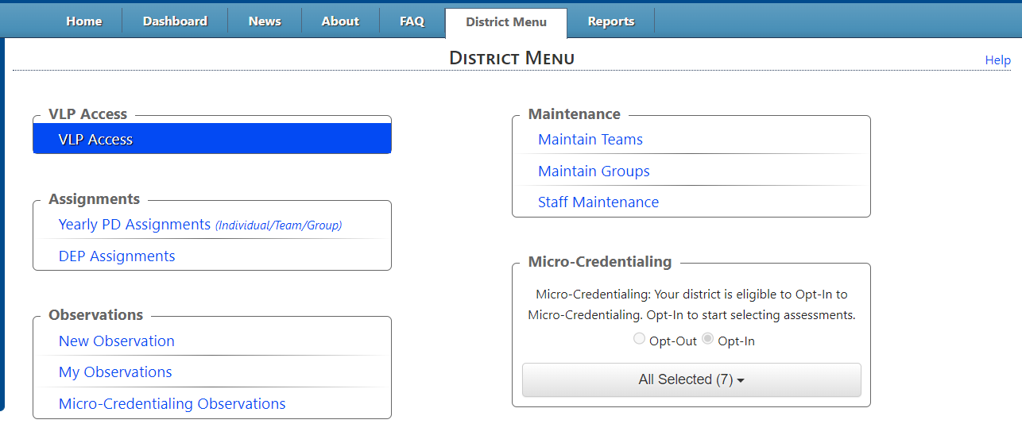
The Team Maintenance page will be displayed. Your Building will be pre-selected and displayed.
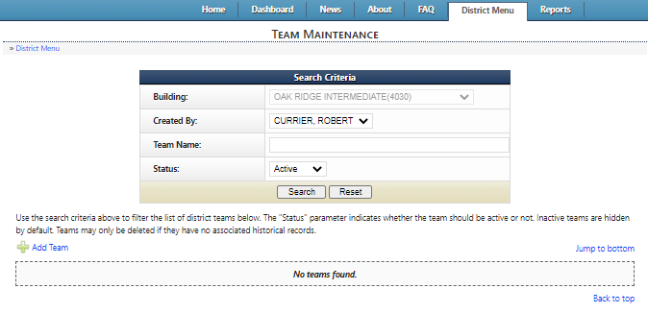
To create a team, click the Add Team link highlighted above
The Maintain Team window will be displayed
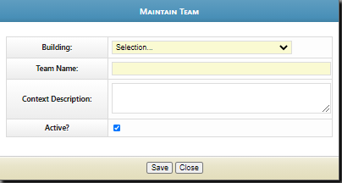

The building will be pre-selected and displayed.
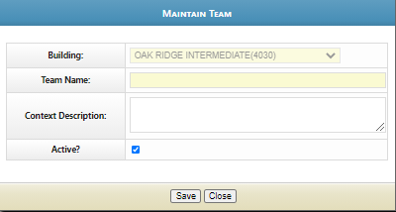
Create and enter the team name, and add the Context Description of the assessment. The Context Description will become the scope statement or lens through with the assessment is taken. Make sure the “Active?” box is checked. When complete, click the Save button, then Close.
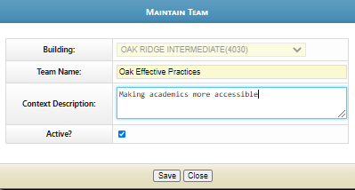
To add members to the team, click the Action: View team members control highlighted below.
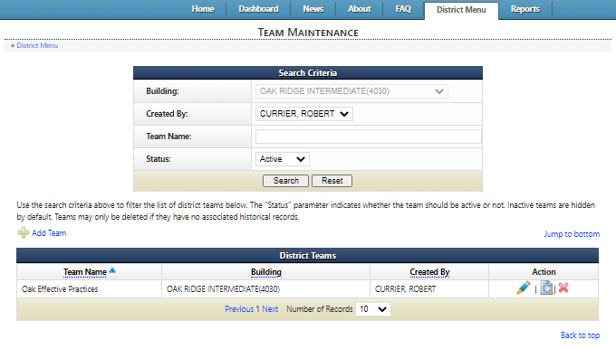

The Member Maintenance page for that team will be displayed.
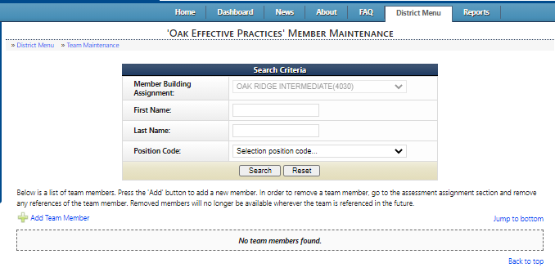
To add team members, click the Add Team Member link highlighted above
The Maintain Team Members window will be displayed
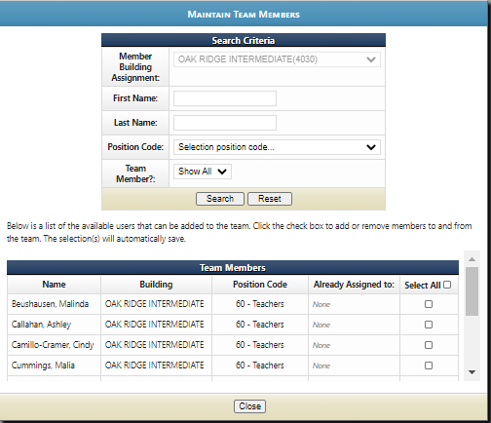

This window allows building admin to choose team members individually by searching for their name(s). As each team member is checked, the “Already Assigned to:” column will change from “None” to the team assigned.
When the selection has been completed, click the Close button.
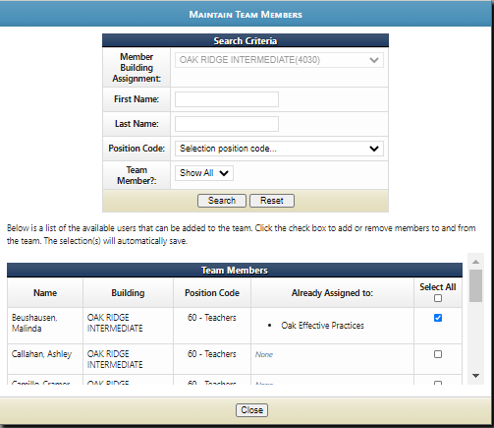
When the selection has been completed, click the Close button.
After this window closes, the list of Team Members will be displayed