Virtual Learning Platform
How to Complete an Observation by Building Administrator
Note: An Assessment is completed by an individual or a team, and closes at the due date that was assigned.
- Click on the “New” button in the Observations box located on the My Building Dashboard or on the “New Observations” link on the district menu as shown below:

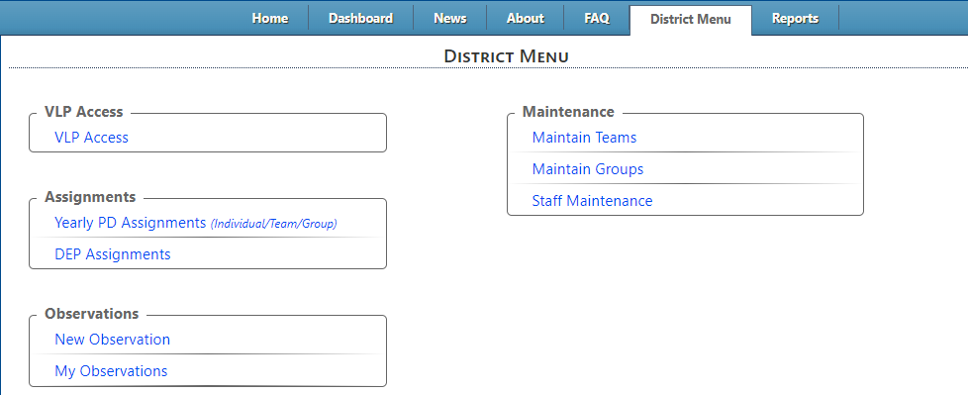
- This will display the Start New Observation page shown below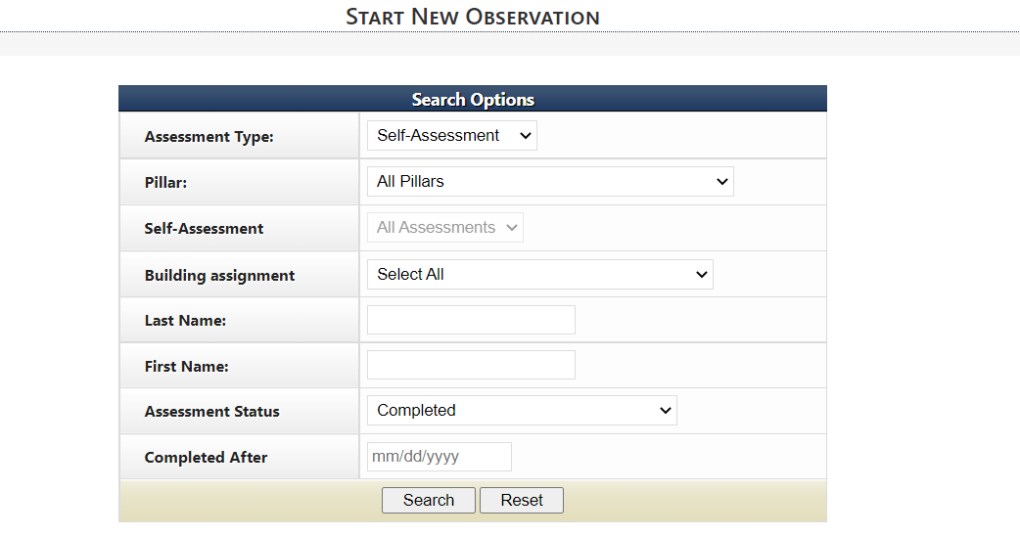
Choose the Assessment Type: either Self-Assessment or Team
Choose the Self-Assessment from the dropdown list
Then either choose the building or search by name
The Assessment Status choices are: Completed – A self-assessment has been completed
No Self-assessment /initial observation – self-assessment has not
been completed
Show All – displays everyone who meets the search criteria
Completed After – this narrows the search to self-assessments completed after the date chosen

After the criteria has been entered click the Search button displayed above
- The results will be similar to the display below and on the same screen as the search criteria box:
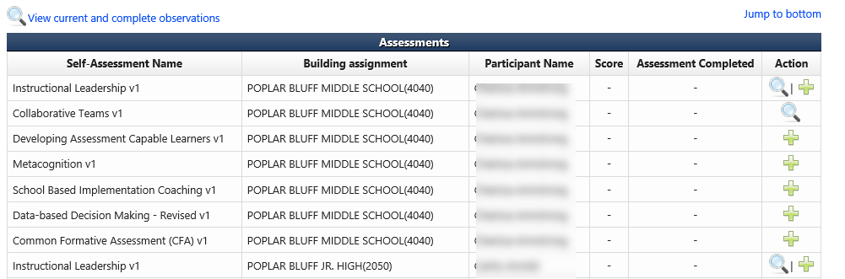

- Click the green plus sign to start the observation
- The observation assessment will be displayed similar to the display below:
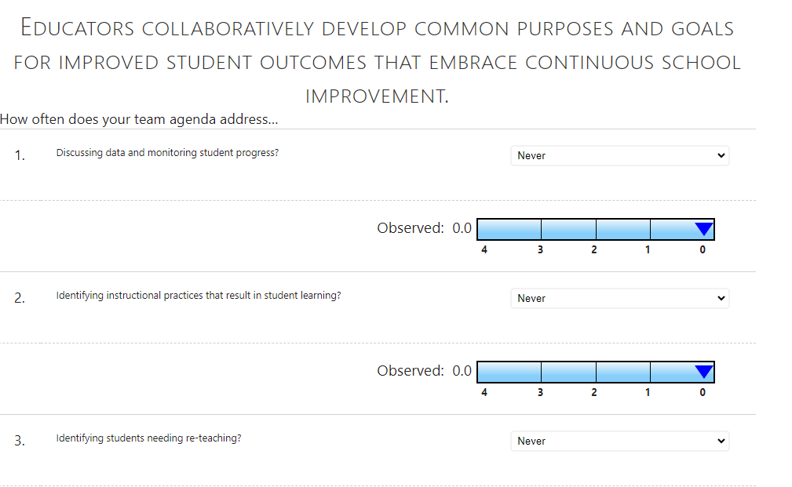
- Either use the slide bar or click on the appropriate place on the scale to mark the questions. (Participant responses will display for each questions if this is not an initial observation and the observation is complete. Team response scores are an average of the total scores given by participants.)
- When complete click the Complete Observation button displayed below
- The observation “heat map” will be displayed similar to below:
