Virtual Learning Platform
Maintain Building and District Users

The following instructions will show how to maintain building and district users while logged in as a District and/or Building Admin.

Access the District Menu and select Staff Maintenance highlighted in blue below:

This will bring up the staff list that can be filtered by building and position code. You can also search by name and username:
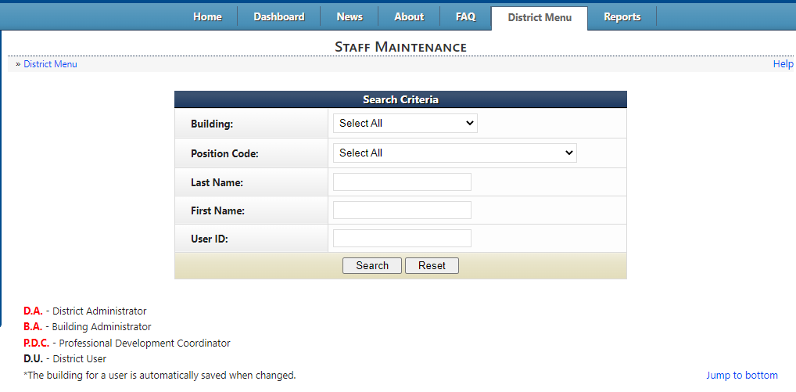

To update a User’s Position code, select the correct code using the drop box outlined in purple:
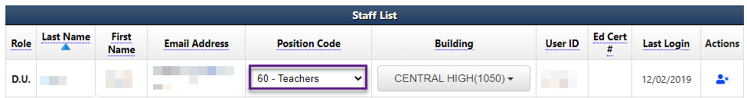

To updates a User’s Building, select the correct building using the drop box outlined in yellow:

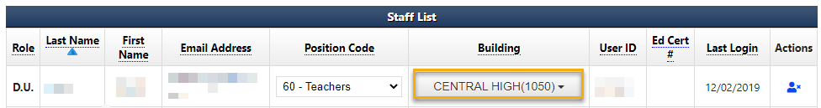
Both updates will save automatically.

To remove a user, select the blue person with an x icon under ‘Actions’ next to the user you want to remove:
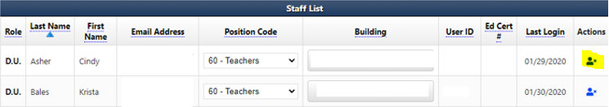

A warning message should pop-up. Select ‘OK’ if you wish to remove the user and ‘Cancel’ if not.

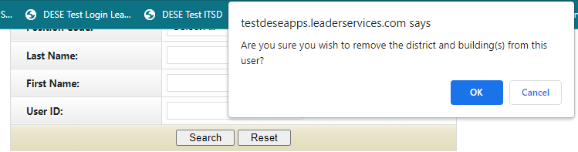

To confirm they have been removed, you can utilize the same page in Staff Maintenance.

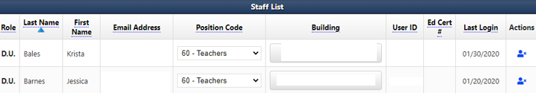
User Cindy Asher was removed and is no longer listed on the Staff List.
To further demonstrate, a screenshot of the list of names that come up when assigning an Assessment is shown below:
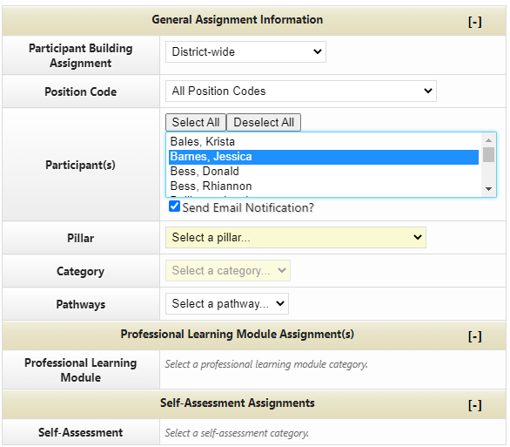
User Cindy Asher was removed and no longer shows as an option when assigning an Assessment.
If a user/users needs to be added, please see the instructions for Adding Users to the VLP from User Manager and Bulk Upload Method of Adding Personnel to the VLP.

