**Virtual Learning Platform**

**Adding District Administrators to the VLP**

1. Log into DESE Web Applications and click the Security Manager link:

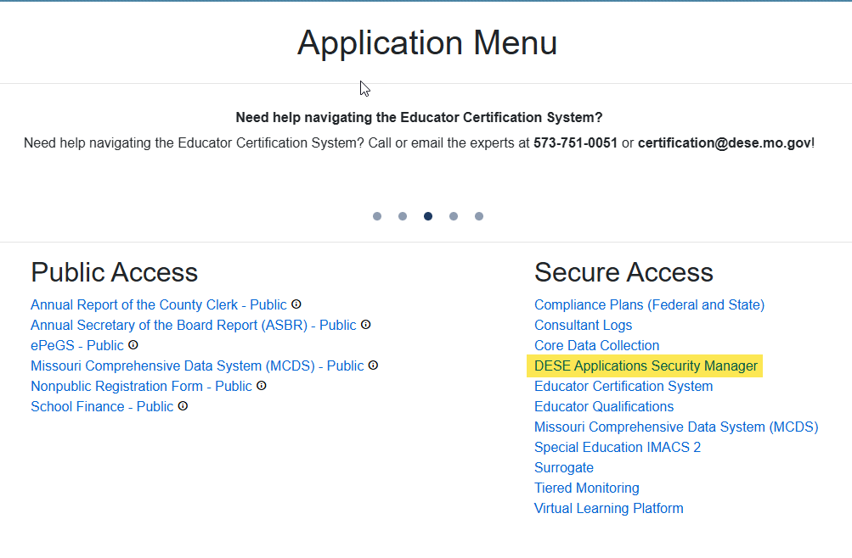If prompted, select your district under Select Organization:

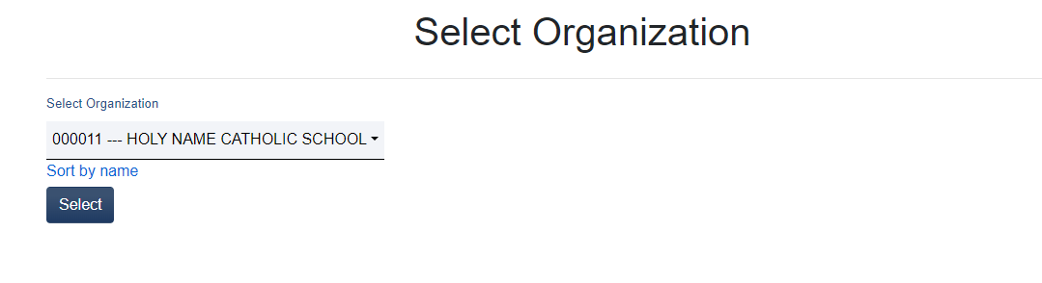

1. On the “User Search” page by entering the username, first and last name, or email to find the correct user.

1. Verify the user information is correct. Select “Edit User Access”

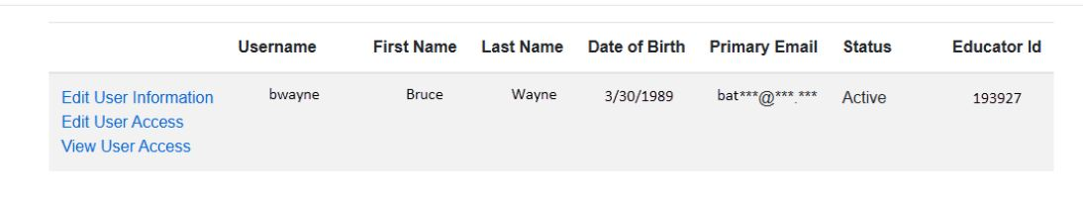

1. Scroll to the Virtual Learning Platform and click on the arrow to expand.

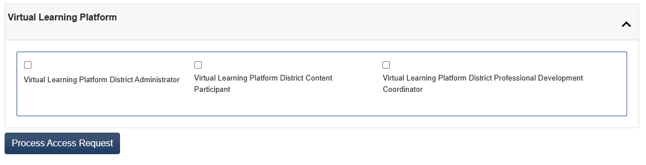

1. To add the District Administrators click the box above Virtual Learning Platform District Administrator and click the Process Access Request button. There will be a pop-up screen to confirm the choice:



**Adding Building Administrators to the VLP**

1. Follow steps 1-3 above
2. Select the appropriate building from the menu at the top. An example is below:

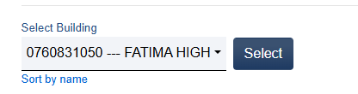

1. Follow step 4 listed above.
2. Click the box beside the Virtual Learning Platform District Building Administrator and click the Process Access Request button. There will be a pop-up screen to confirm the choice.

