Virtual Learning Platform
How To Add New Users to the VLP as a User Manager
Pictured below are the various security roles available for VLP through User Manager. With each role, there is a note on who should be granted that access and what that access has the ability to do within the application.
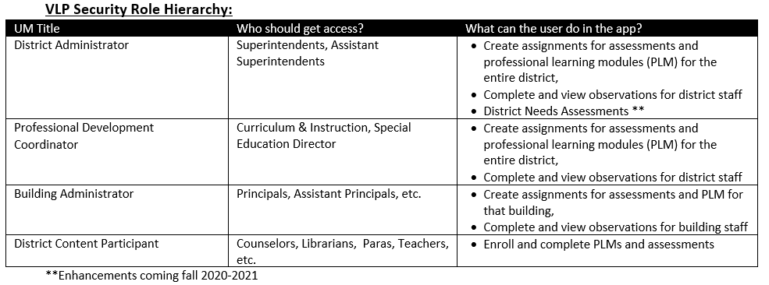

Adding District Administrators to the VLP
- On the dese.mo.gov website, click Web Applications as highlighted below: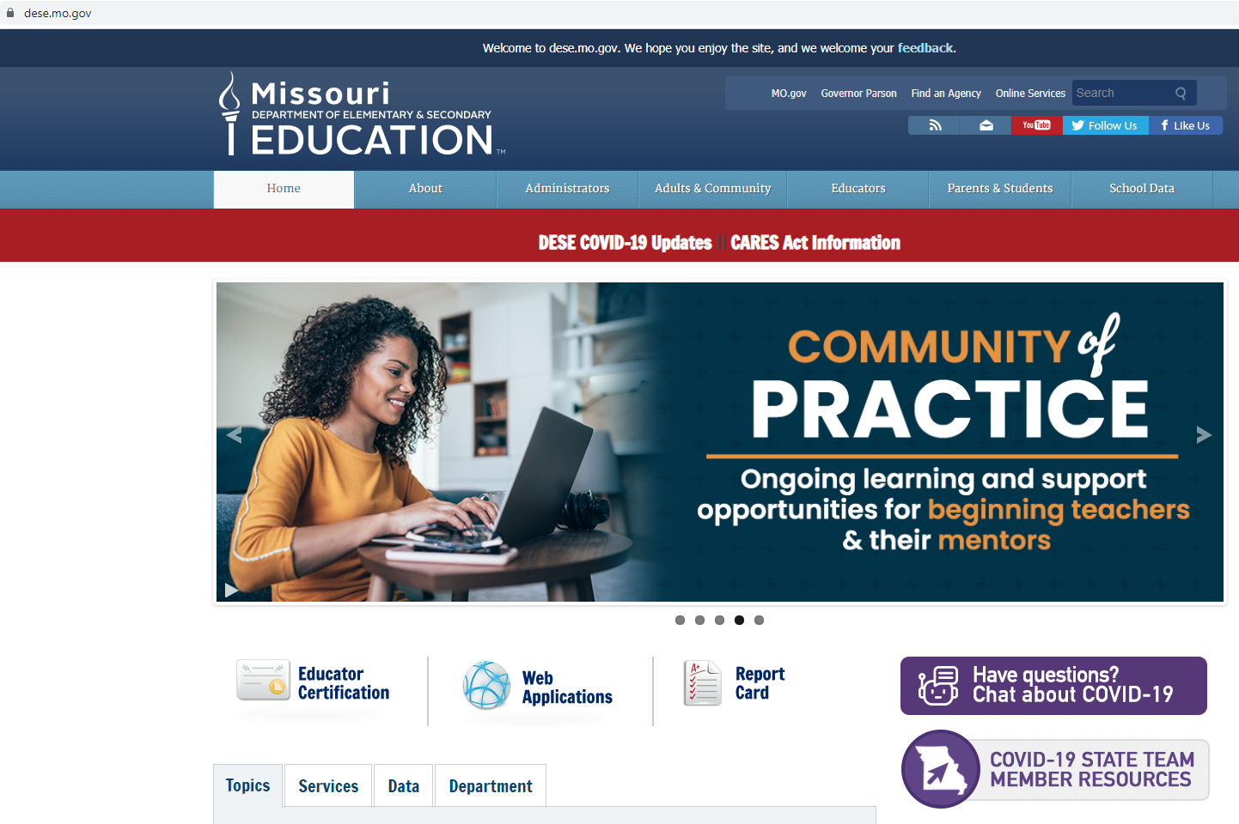
- Enter your username and password and login: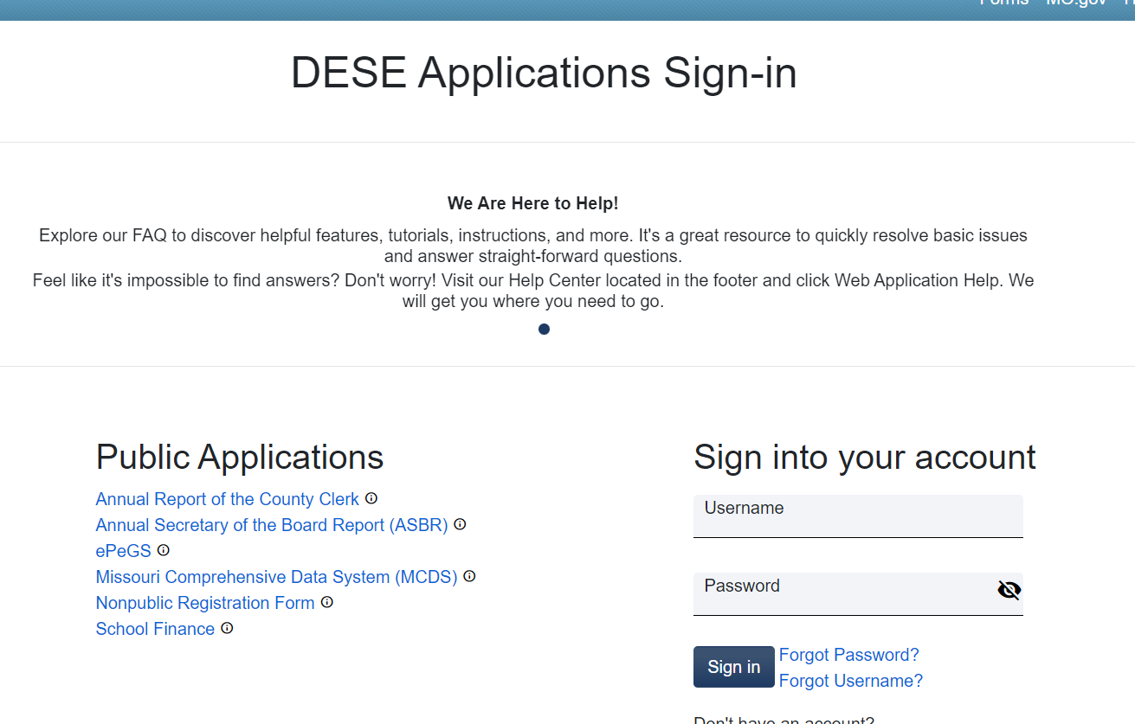

- Click the User Manager link
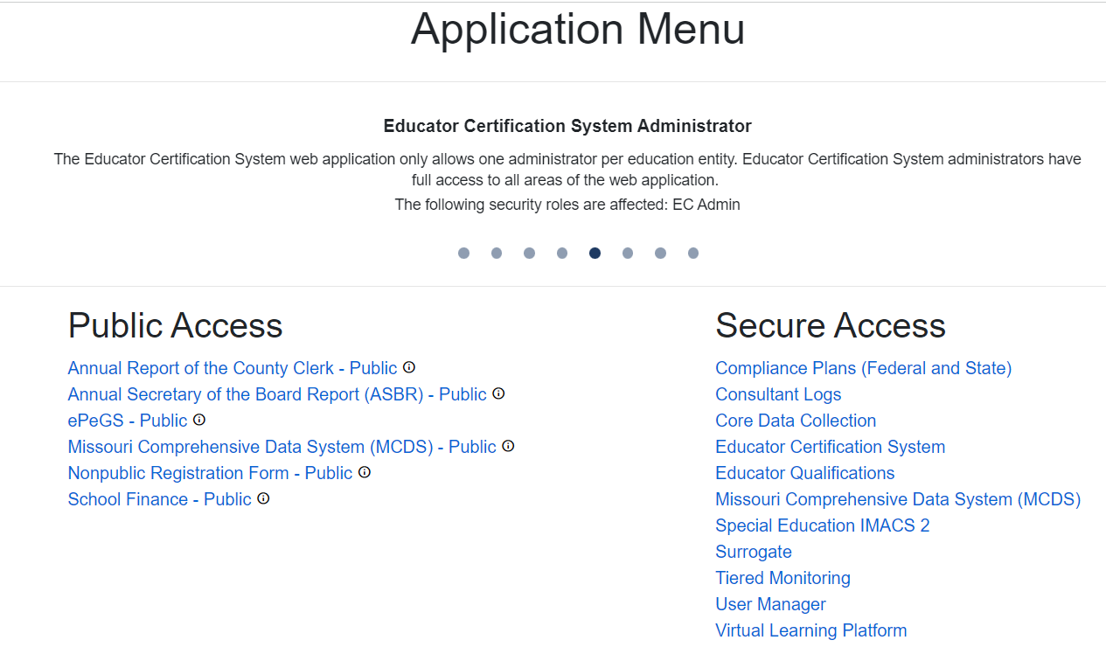
- Select your district.

- Click the User Access link
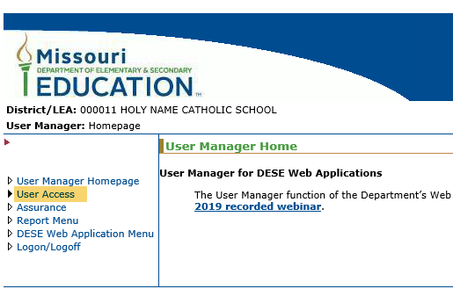
- This screen will be displayed
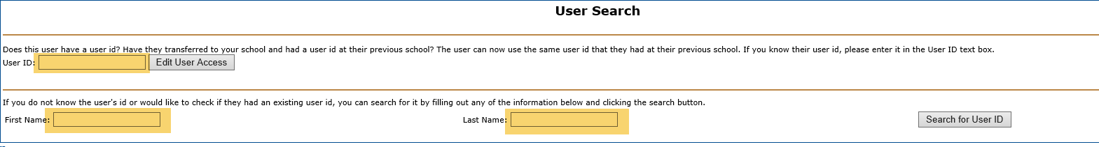
- Enter the appropriate information and click the Edit User Access button
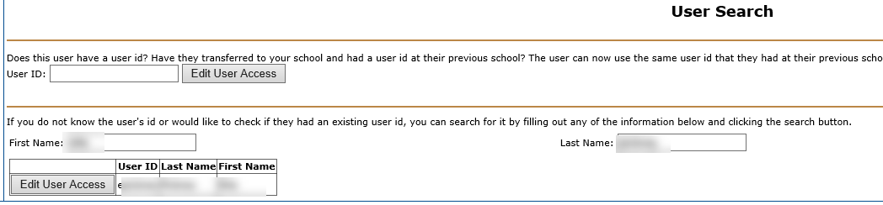

- At the top you will see:
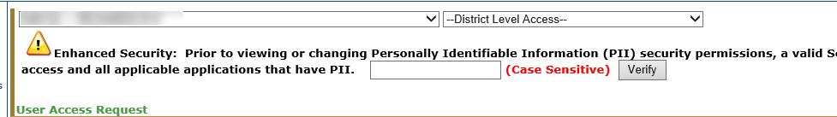

- At the bottom you will see a menu similar to what is below:
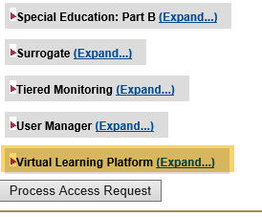

- Click expand on the Virtual Learning Platform button and this will be displayed:
To add the District Administrators click the box by the label Virtual Learning Platform District Administrator and click the Process Access Request button shown above. There will be another screen to confirm the choice.
To add Building Administrators to the VLP
- Repeat steps 1 through 6

- At this point you need to select the building from the menu at the top. An example is below
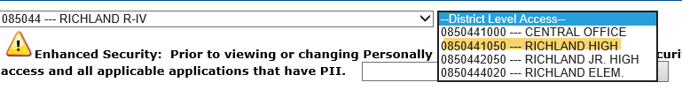

- When you select a building the screen becomes much smaller as displayed below: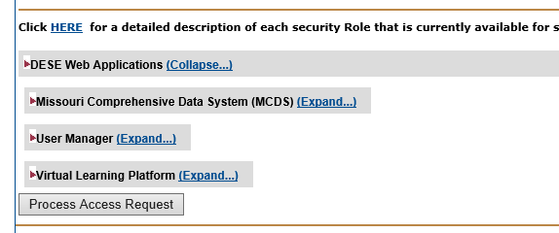
- Clicking on the expand button displays the following:
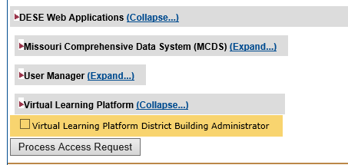
- Click the box beside the Virtual Learning Platform District Building Administrator and process as before.

To add District Content Participants
Adding content participants can happen at any time, but usually used after the October MOSIS update of your current school year.

- Repeat steps 1-9

- Click expand on the Virtual Learning Platform button and this will be displayed:

- To add the District Content Participant click the box by the label Virtual Learning Platform District Content Participant and click the Process Access Request button shown above. There will be another screen to confirm the choice.

To add District Content Professional Development Coordinators

- Repeat Steps 1-9

- Click expand on the Virtual Learning Platform button and this will be displayed:

- To add the District Content Participant click the box by the label Virtual Learning Platform District Professional Development Coordinator and click the Process Access Request button shown above. There will be another screen to confirm the choice.

