Virtual Learning Platform
How to Use the Bulk Upload Method of Adding Personnel to the VLP
Building and district administrators may add personnel to the VLP via the bulk upload feature described below. Note: to add users to the VLP they first must have a web apps account. This is for users added after the October MOSIS process of your current school year.
- Create a file for those needing access. The easiest way is to use the file provided. The required fields are Last Name, First Name, and DOB.
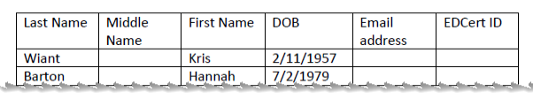
After the names have been added, save the file to a convenient location (I generally use the desktop). Be sure to save the file as .csv.
- Sign into the VLP. The admins should see the menu below:
- Click the District Menu tab shown above
- The following should be displayed (note this is a partial screen)
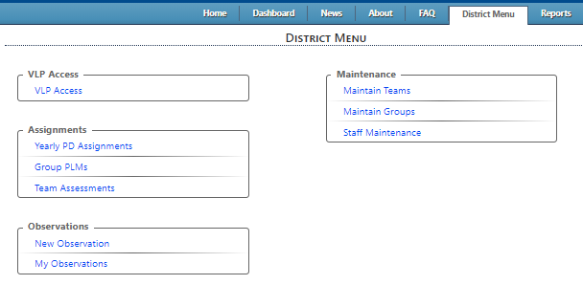

- Click on VLP Access as highlighted above and the following will be displayed: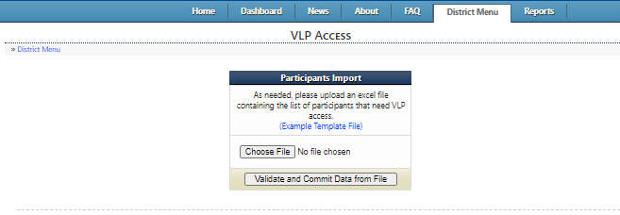

- Click on the Choose File button to locate the file created in step 1 and a screen similar to the one below will be displayed.
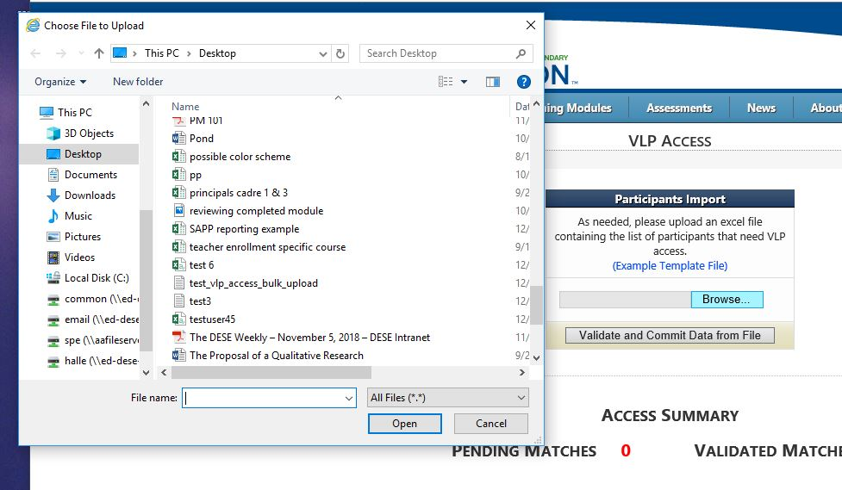
Click on the file and then click the open button.
- The following screen should be visible: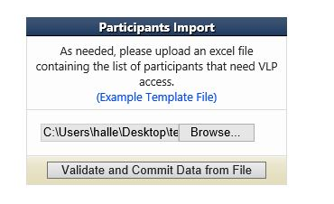
Click the Validate and Commit Data from File button
- The following screen should then be visible:
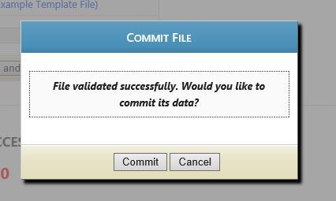
Click the Commit button.
- The results will be displayed as in the example below:
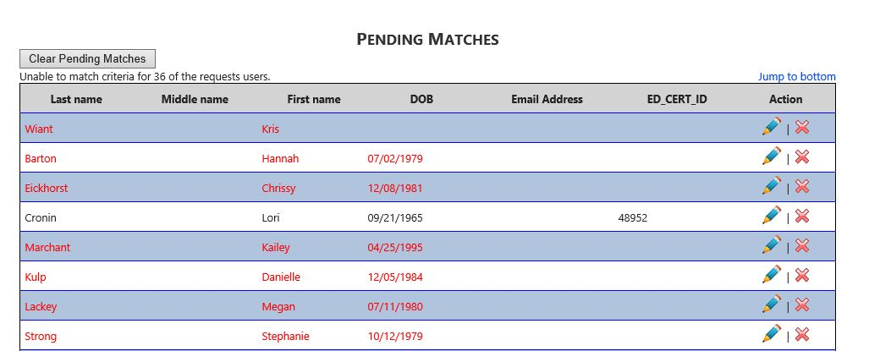
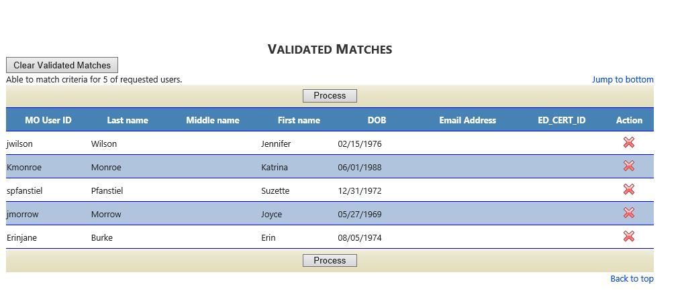
Matches that are “Pending” are those that require some editing before they can be processed. The data may be edited by clicking the pencil icon or deleted by clicking the red X.
Validated matches are those that can be given access to the VLP immediately by clicking the process button.

