Virtual Learning Platform
How to Add Group Members to an Established Group
Click on Maintain Groups from the District Menu page:

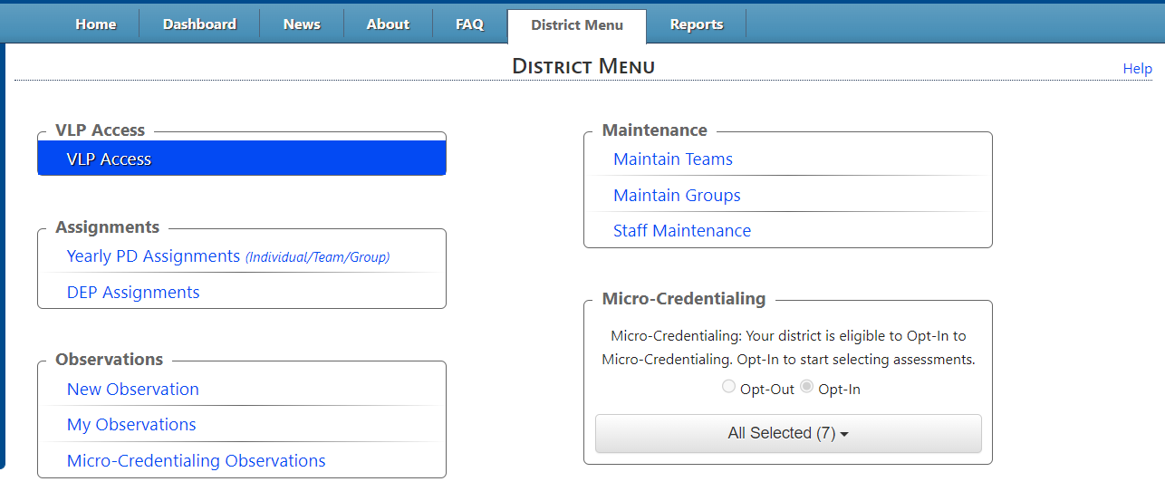
The Group Maintenance page will be shown:

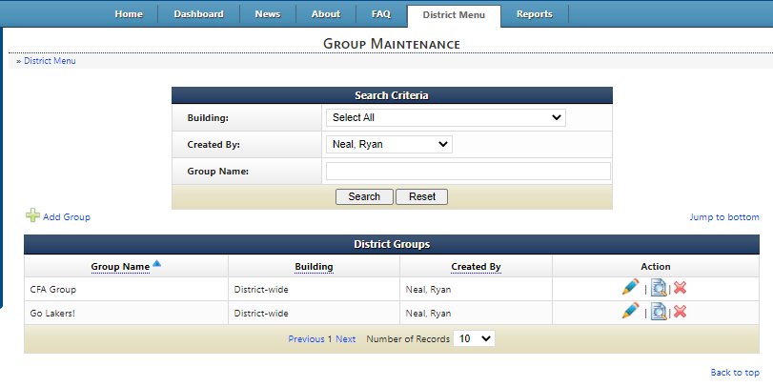

In this example, for the Go Lakers! Group, click the Action: View Group Members edit link highlighted above and the Member Maintenance page will be displayed.

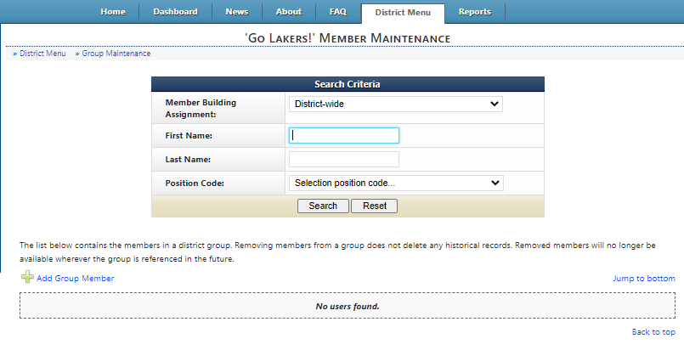
To add group members, click the Add Group Member link highlighted above and the Maintain Group Members is displayed.
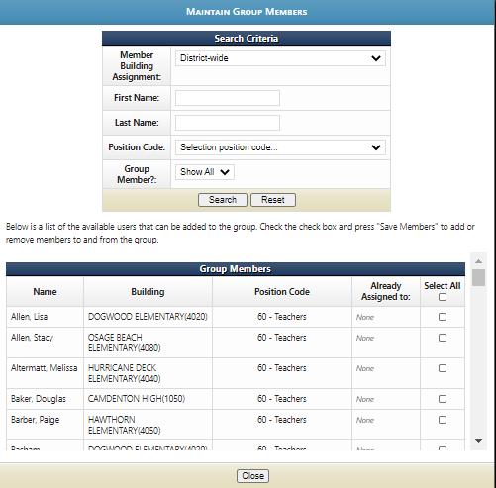

Group Members can be added by selecting Member Building Assignment, First Name, Last Name, Position Code, and then by selecting Search. A member is then chosen by clicking the Select All checkbox or by clicking the checkbox on the person’s row. The selection process is dynamic, meaning if a building is selected and the person or persons are chosen and then a different building is chosen, those previously selected will be added to the group.
