Virtual Learning Platform
How to Assign a Team Assessment by District Administrators
To assign an assessment, return to the District Menu page and click Yearly PD Assignments (Individual/Team/Group).
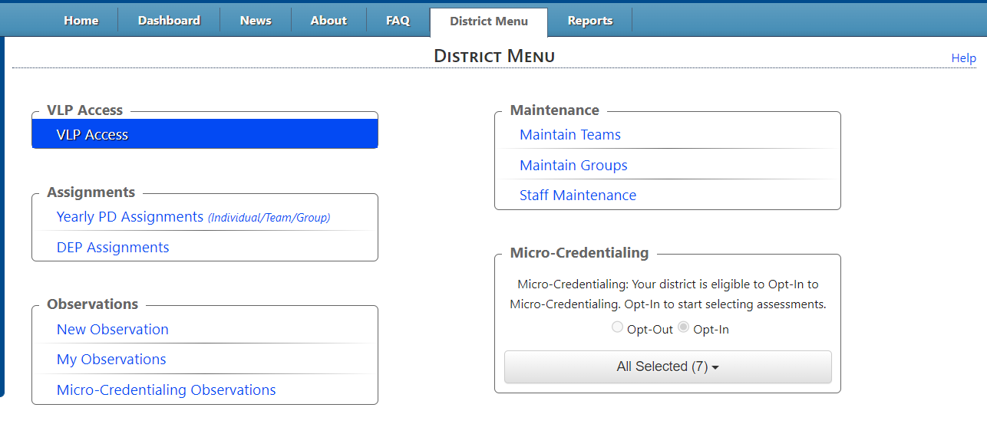
Then Assignments page will be displayed.
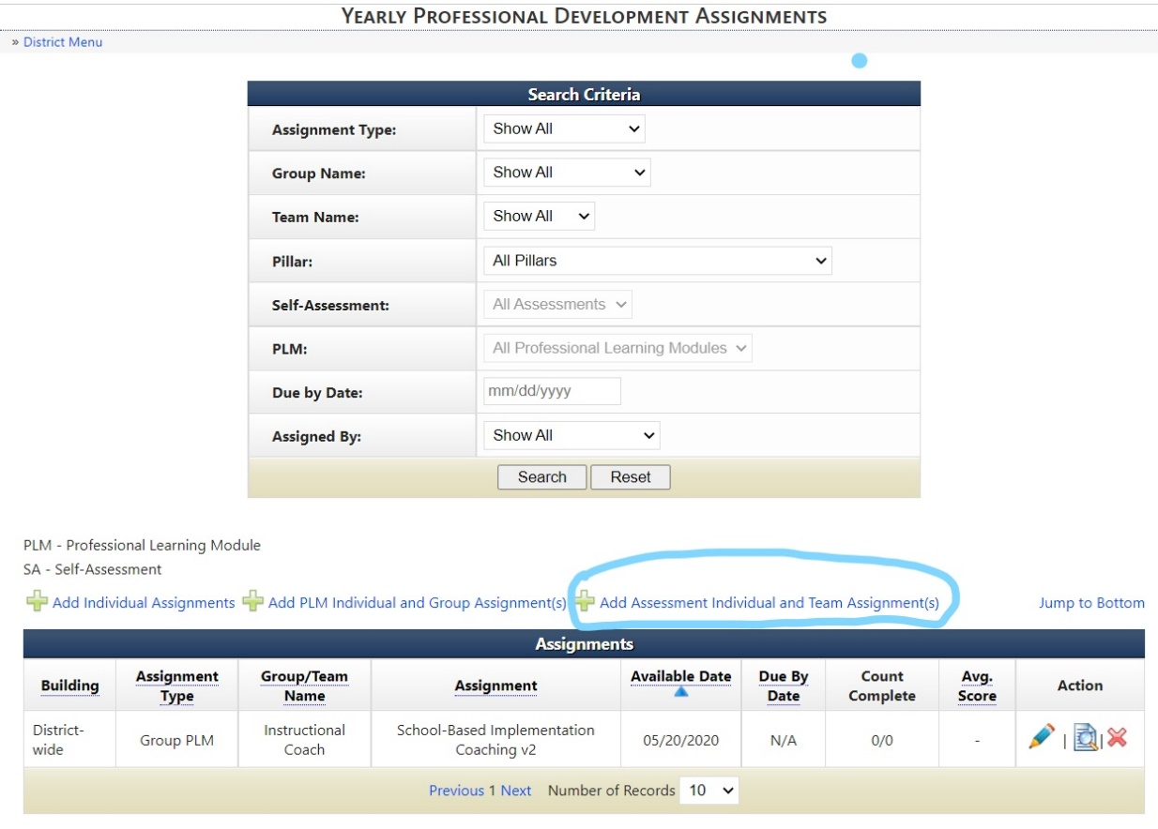
To assign an assessment, click the Add Assessment Individual and Team Assignment(s) link circled in blue above. Then the Add Assessment Assignment window will be displayed.
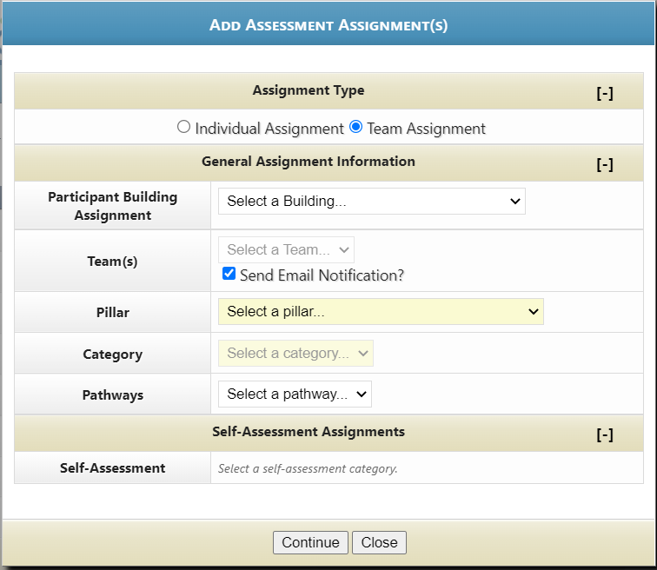
Select the Team Assignment button. Then use the dropdowns. First select the correct Participant Building Assignment. Then select the correct Team. Select the Pillar, then the Pillar Category, and then the Pathway.
Then select the correct Self-Assessment. When you select the correct self-assessment the window will change.
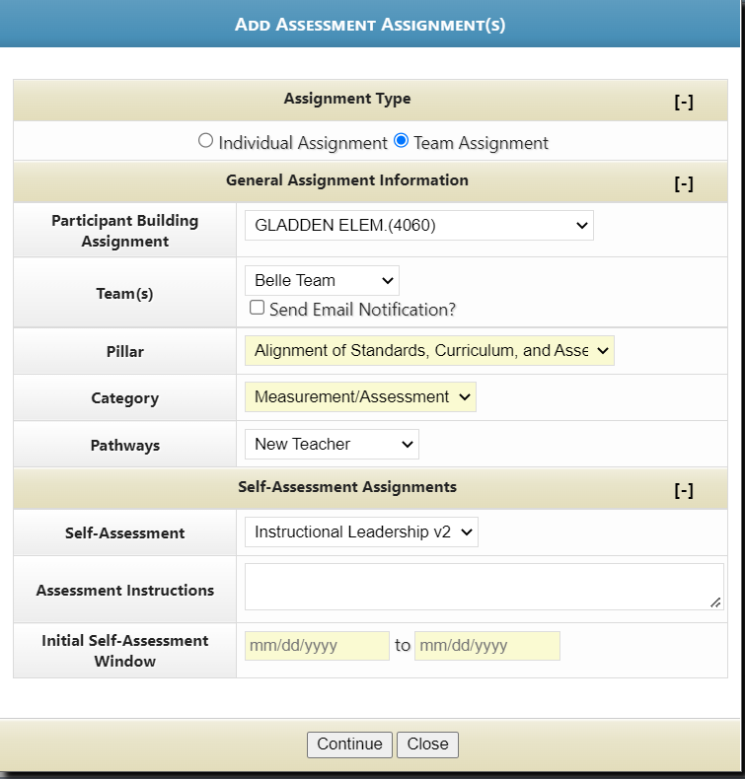

You can add in instructions, and create a window of time the assessment needs to be completed.
Select your Window dates from the calendars shown below.
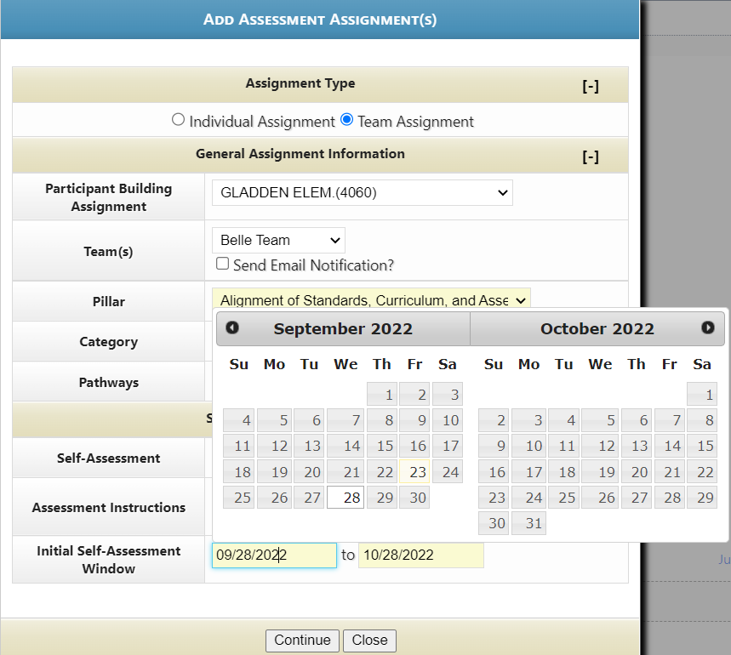
Then hit Continue.
The assignment will be displayed on the Yearly Professional Development Assignments page
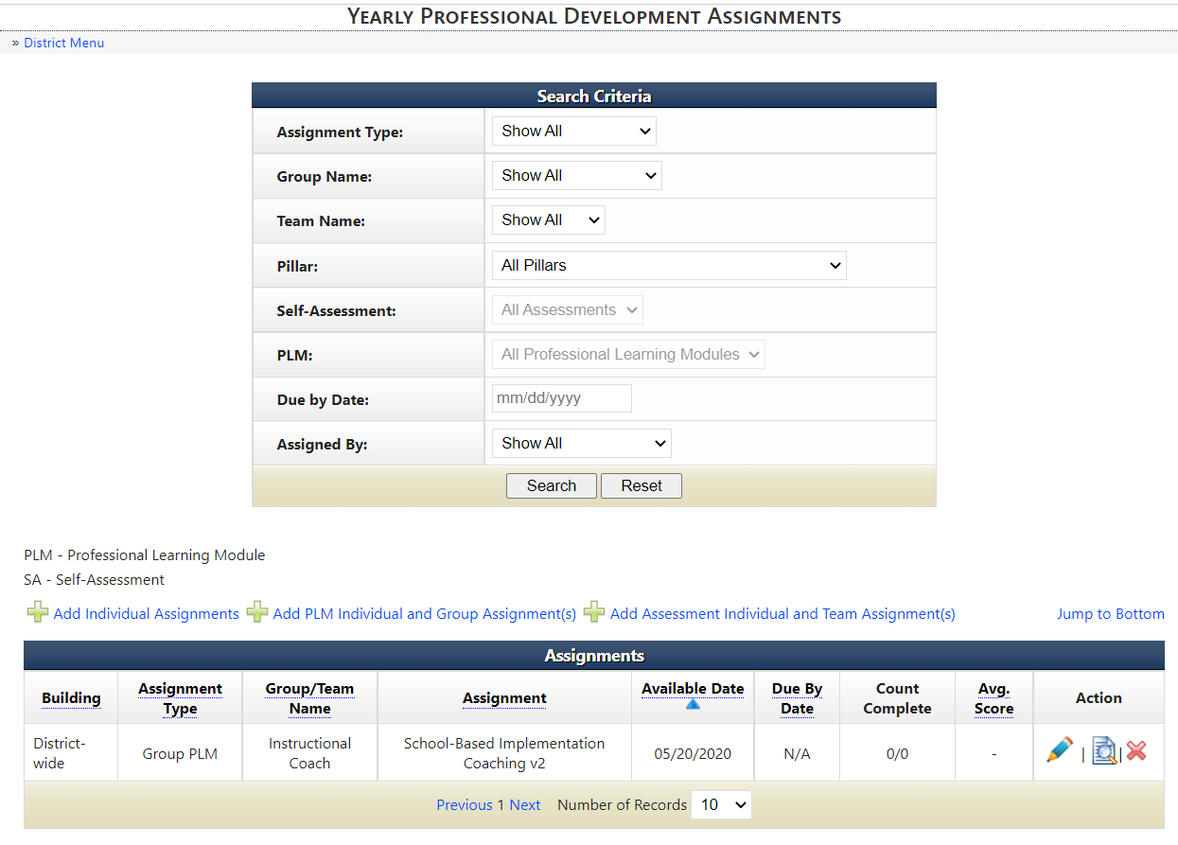
Assessment information overview will be displayed on the Dashboard in the “My District Dashboard section. By using the dropdown to select the correct year, checking the “Teams” box, and using the Teams dropdown to select the correct team. This shows all assessments. Select a specific assessment using the dropdown in Team Assessment overview. A graph of assessments completed can also be viewed in this section.
