Virtual Learning Platform
How to Create a Group by District Administrator
What is a group?
A “group” is composed of staff selected by their district or building administrators to complete a Professional Learning Module (PLM). For example, a group can be established for new staff in the district to study the material used by the district in a previous year, or for selected members to become knowledgeable of the material in advance of the rest of the district so they can act as Instructional Coaches.
In this example, a district decides the focus for the year is Common Formative Assessments and the training will be held in group settings throughout the first semester. The district administrator forms a group consisting of all the teachers and administrators of the district. When the training has been completed, the district administrator will mark the training as complete, which will, in turn, update the VLP record of all the participants as having completed the Common Formative Assessment module.
Creating and Maintaining a Group by a District Administrator
To create a group, click the Maintain Groups link found under the Maintenance header in the District Menu page.
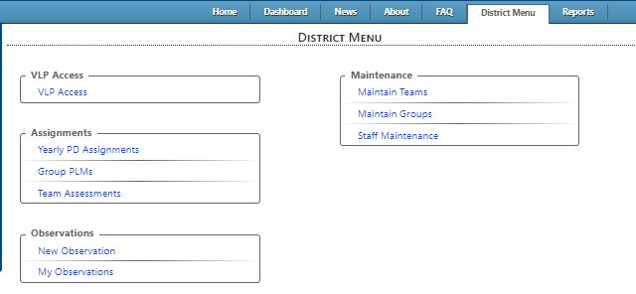

The Group Maintenance page will be displayed
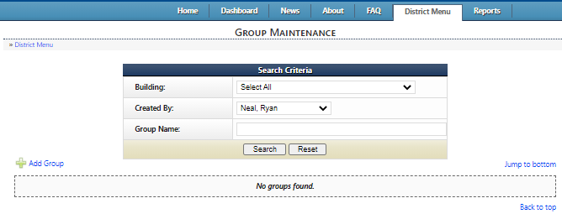

To create a group, click the Add Group link highlighted above. The Maintain Group window will be displayed.
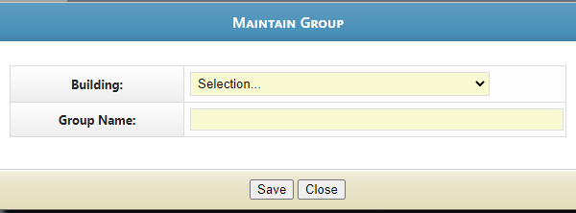

Select the building – in this example District Wide -- and add the Group Name.
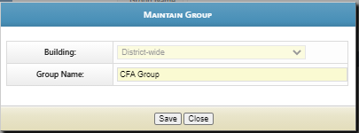
Save and Close the Maintain Group screen.
The group will be displayed in the Group Maintenance page
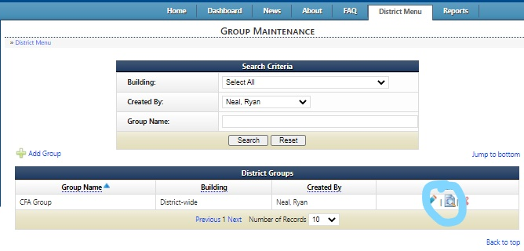

How do I add Group Members at the time the group is formed?
To add Group Members click the Action: View Group Members edit link circled in blue above and the Member Maintenance page will be displayed. This is the Magnifying Glass over the page icon.
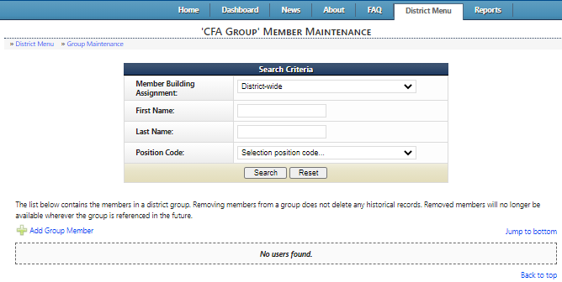

To add group members, click the Add Group Member link highlighted above and the Maintain Group Members is displayed.
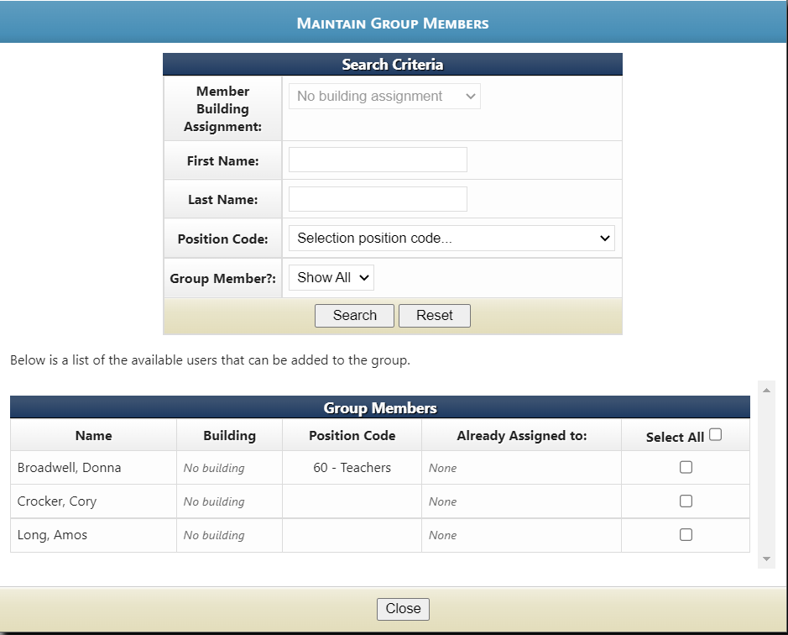

A district administrator can then add Group Members by either:
- Searching for staff in the top Search Criteria box or in the Group Members box by checking Select All
- Scrolling through Group Members and checking Select All or specific people.
Searching for Staff:
Enter Member Building Assignment, First Name, Last Name, or Position Code, and then select Search. A member is then chosen by clicking the Select All checkbox or by clicking the checkbox on the person’s row. The selection process is dynamic, meaning if a building is selected and the person or persons are chosen and then a different building is chosen, those previously selected will be added to the group.
In this example, a search will be conducted on district-wide teachers.
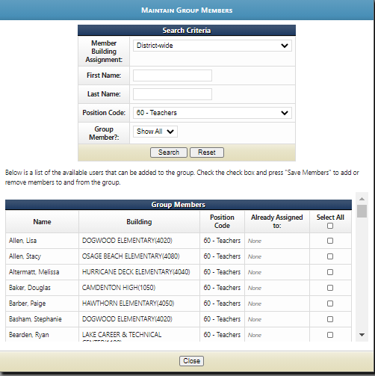
After the search is complete, check the Select All box or the box in the row of the particular teacher to be added to the group. Individual staff can be selected one at a time. Once all staff members have been selected they will all automatically load at the same time.

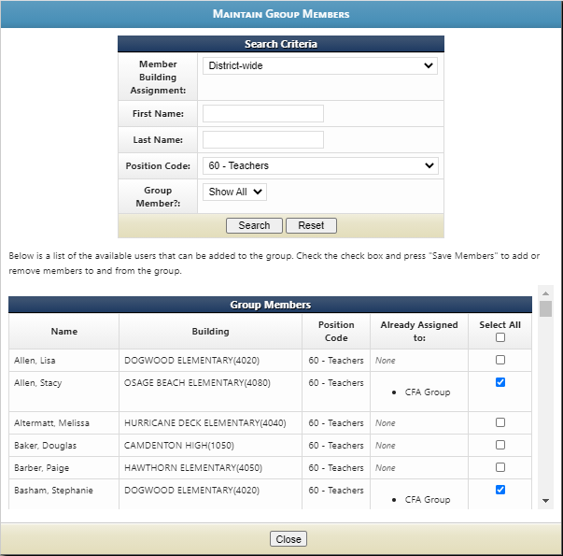

Close the window when you have finished selecting group members.

By scrolling through Group Members:
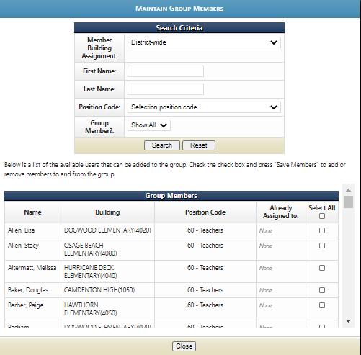
In this screen, in the Group Members box, check Select all or for each individual staff member you choose.
This is what the screen looks like after Select All is checked:

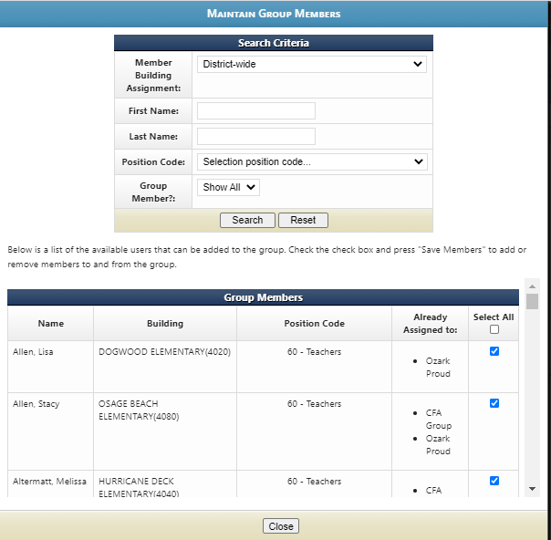

This screen shows the Group Members have been added to the team, “Ozark Proud”.
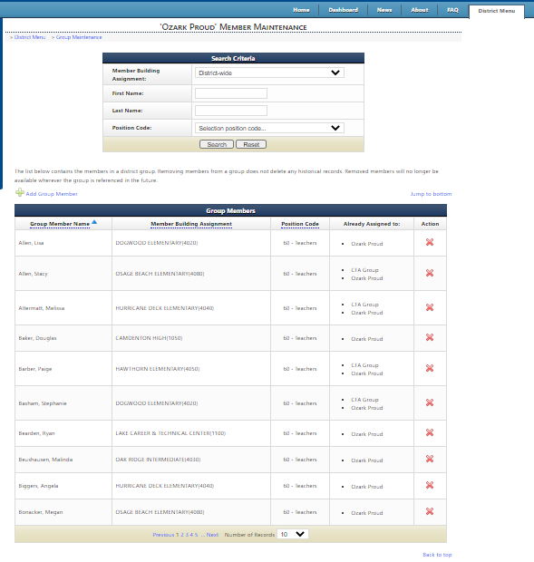
To assign a PLM to a group, go to the District Menu tab and click the Yearly PD Assignments (Individual/Team/Group) link under Assignments.
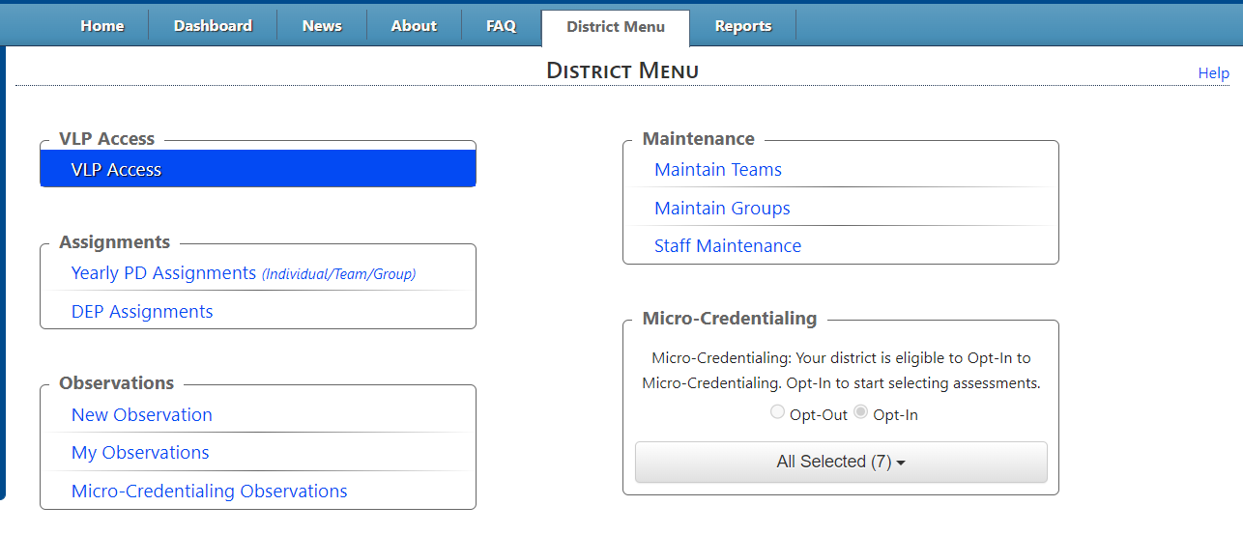
The Yearly Professional Development Assignments page will be displayed
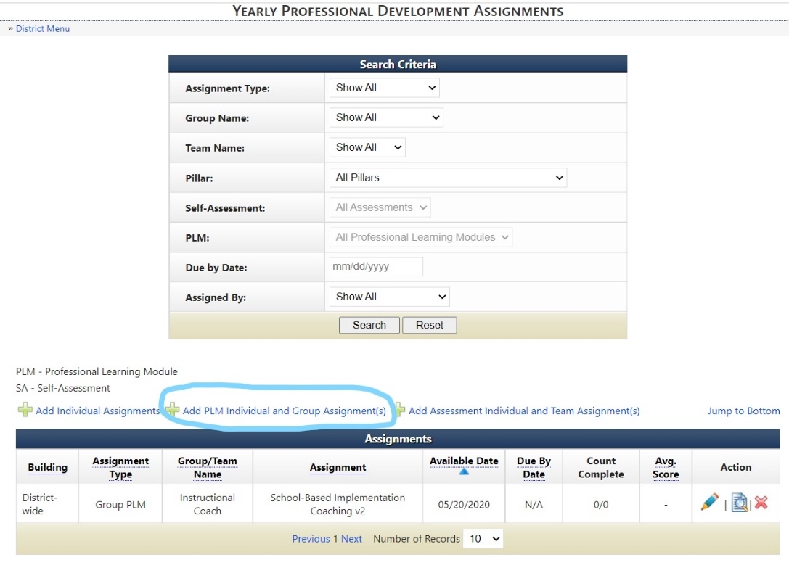
To assign a PLM click the Add PLM Individual and Group Assignment(s) link circled in blue above.
The Assign PLM window will be displayed
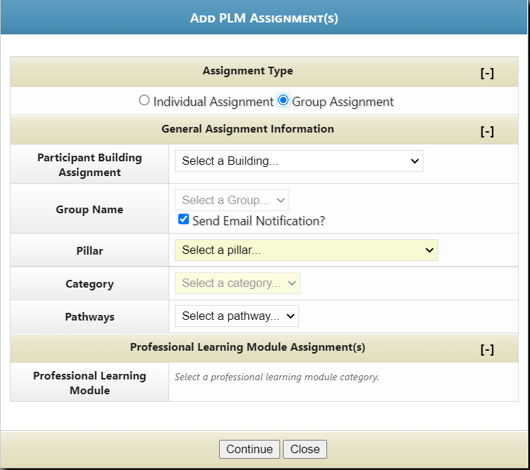
Select Group Assignment.
Use the drop down boxes to select the building, then the select the correct Group. Then select the Pillar. Then select the PLM, the Professional Learning Module. When this has been completed, click the Continue button.
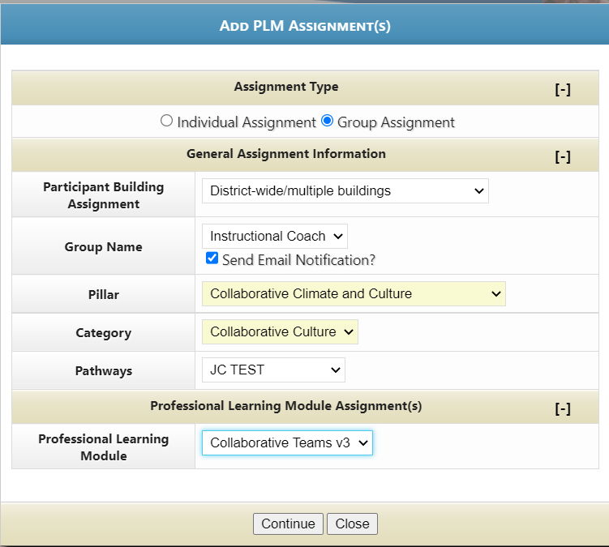
When the module is selected the completion window selection will show like so: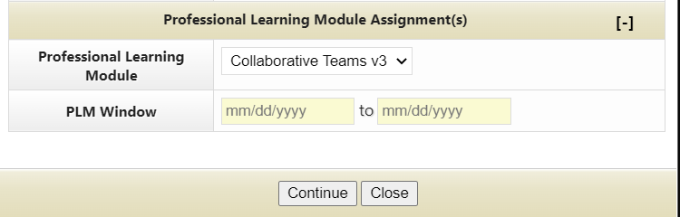
Select your dates from the calendar
: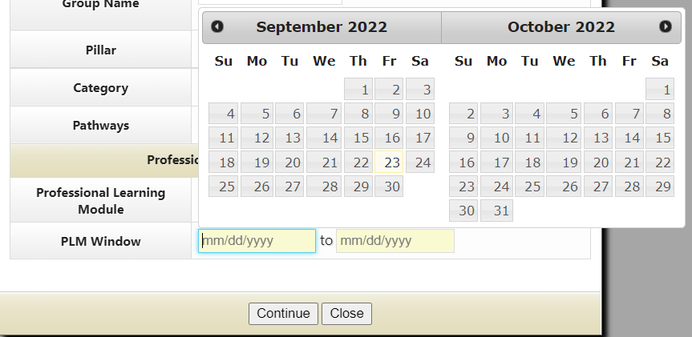

After the assignment is made, it will be displayed at the bottom of the Yearly Professional Development Assignments page.
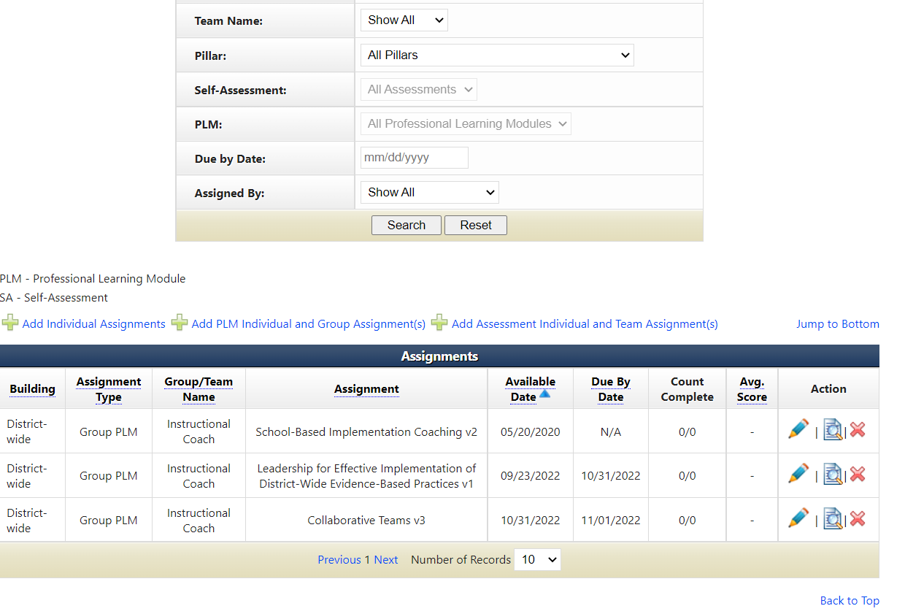

PLM Completion
When the training sessions for the PLM have been completed, the PLM Assignment can completed.
To start, navigate to the Yearly Professional Development Assignments page from the District Menu.
The Yearly Professional Development Assignments page will be displayed.
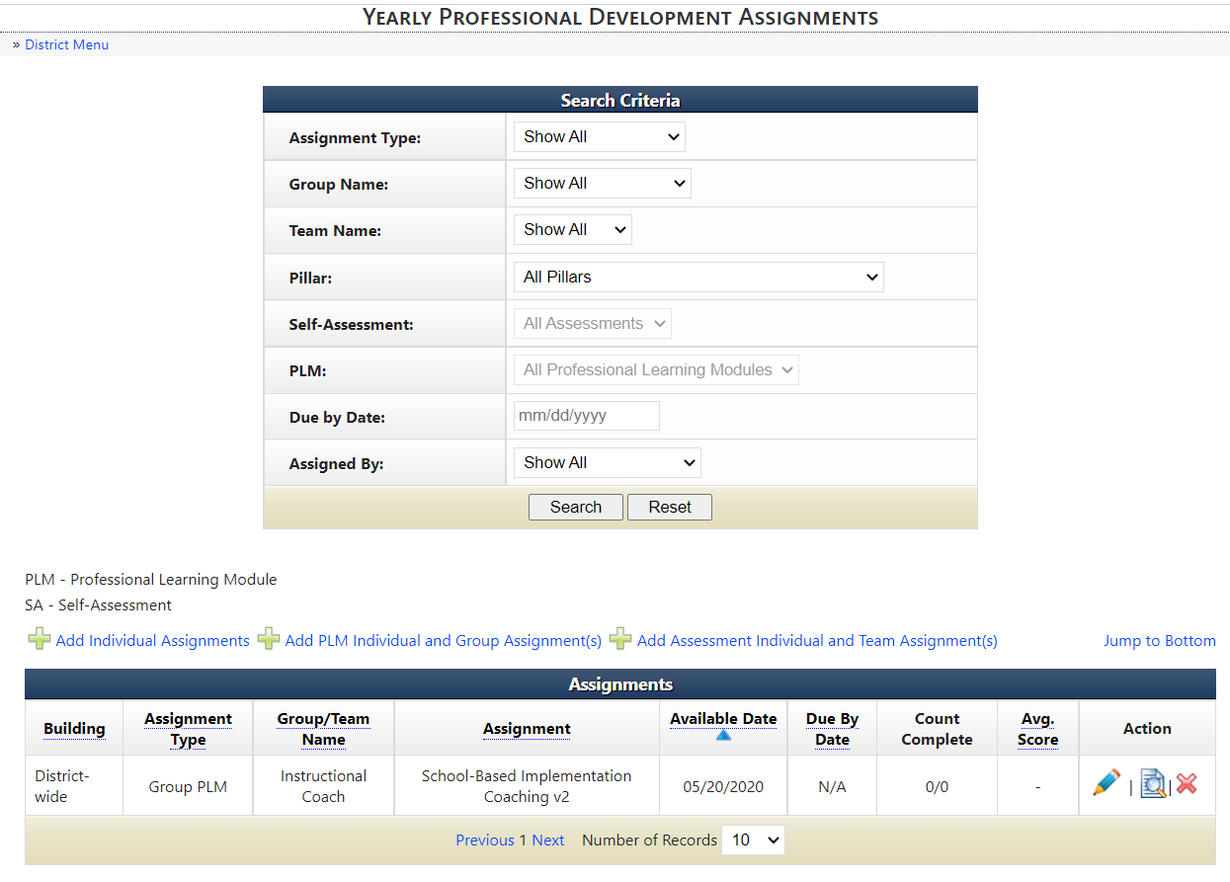
You can search by group by selecting the group name, then scrolling to the bottom to see the assignments for the group. 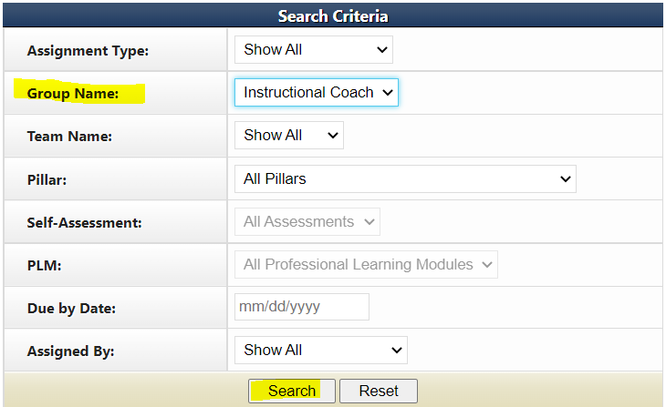
Click the Action: View PLM Participant Records link (magnifying glass with page icon) that corresponds to the PLM assignment to be completed.
The Complete PLM Assignment page will be displayed. 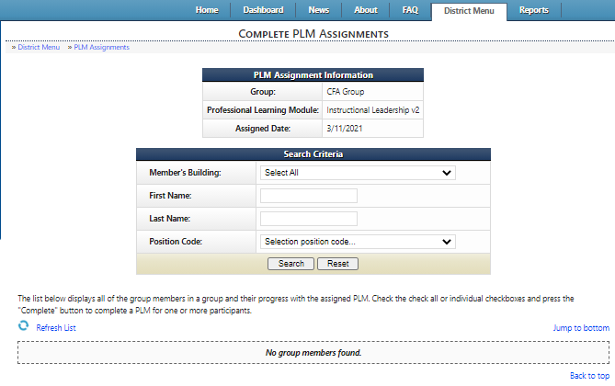

In this window participants can be marked off individually, sorted by building and marked complete, or by checking the Check All checkbox. Once the selection is made enter a completion date and click the Complete button.
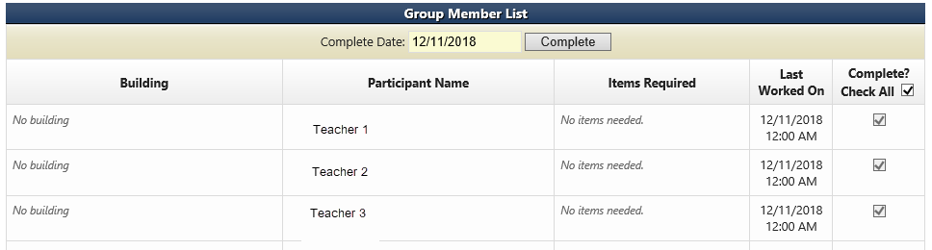
A confirmation window, displayed below, will require that either the Confirm or Cancel button is pushed.
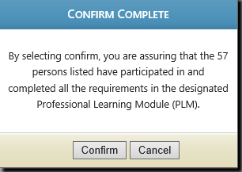
Once the confirm button is pushed the records of everyone in the group will be marked complete for the PLM. Note: this action cannot be undone.
The individual check boxes for the group members will be checked after the update is completed.

