Virtual Learning Platform
How to Create a Team by District Administrator
What is a Team?
A team is composed of personnel chosen to complete an assessment by changing the lens from the self-assessments of teachers and administrators reflecting upon their personal practices to the lens of answering the question of how we are doing as a grade level, as a building, as a district, etc.
Log into the DESE WebApps site to get to the Virtual Learning Platform home page.

Creating and Maintaining a Team
In this example, a district administrator will form a team consisting of all the administrators in the district to see how they rate the “entire team” in implementing Instructional Leadership. The lens of the assessment changes from “how am I doing” to “how are we doing.” The Self-Assessment for Instructional Leadership is then turned into a team assessment by the addition of a “scope statement” at the top of the assessment. The assessment would then be completed and the results viewable via reporting.
Click on the District Menu tab.
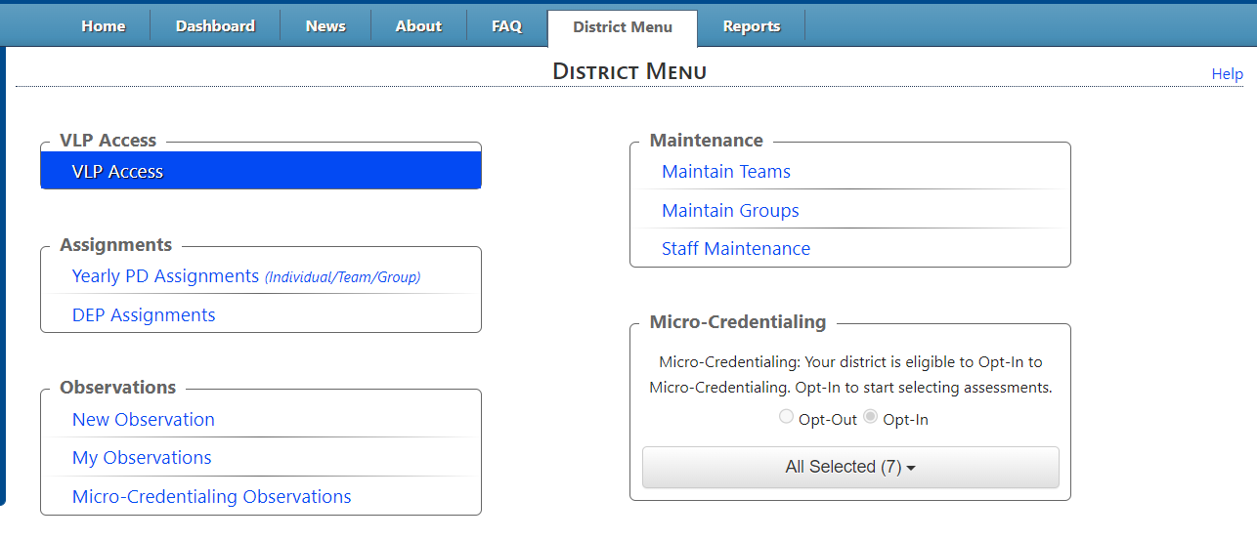
To create a team. Click on the Maintain Teams link under the Maintenance header in the District Menu window.

The Team Maintenance page will be displayed
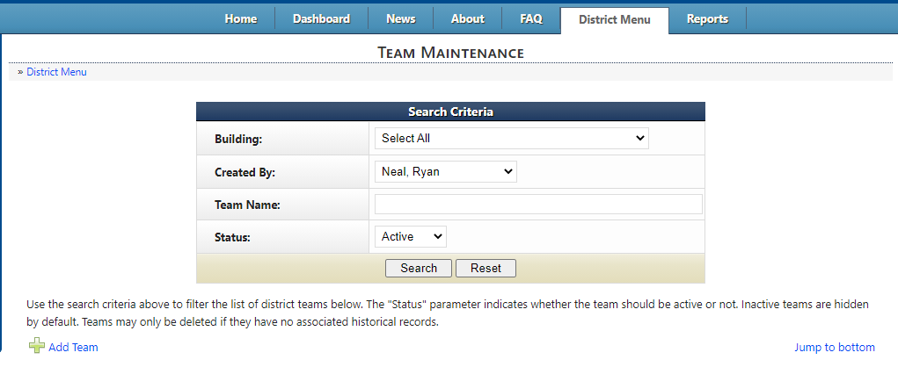
To create a team, click the Add Team link highlighted above

The Maintain Team window will be displayed
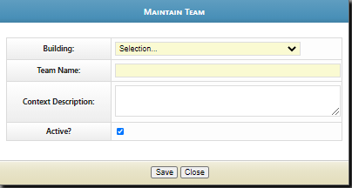

For the Building, select District-wide or the building, create and enter the team name, and add the Context Description of the assessment. The Context Description will become the scope statement or lens through with the assessment is taken. Make sure the Active? box is checked. When complete, click the Save button, then Close.
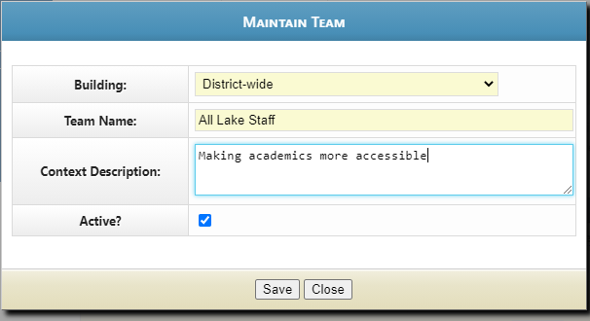

To add members to the team, click the Action: View team Members button that corresponds to the team you want, highlighted below.
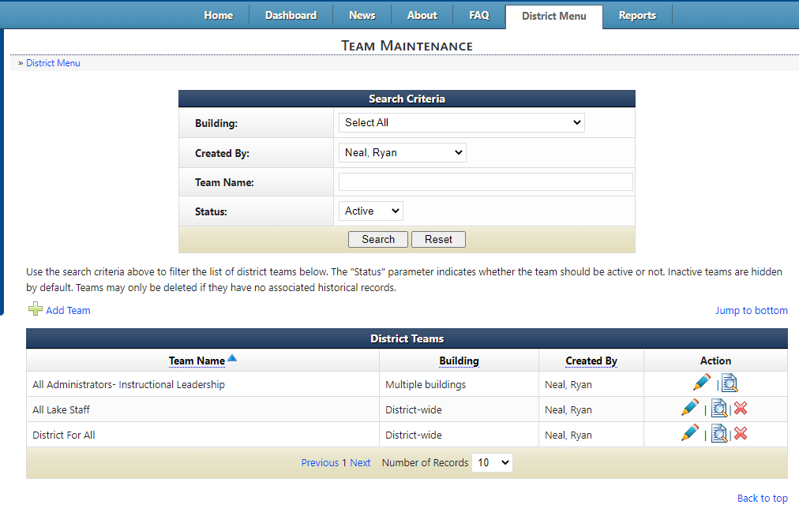
The Member Maintenance page for that team will be displayed.
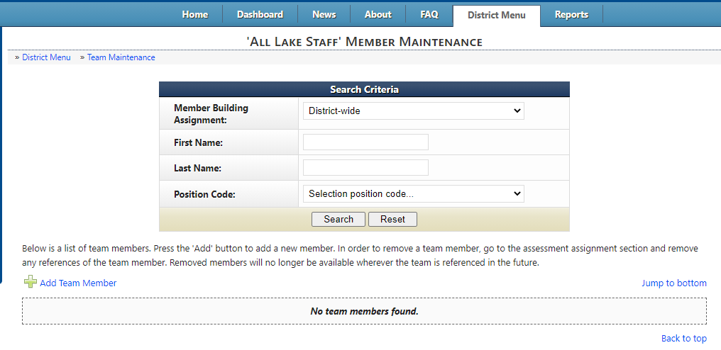
To add team members, click the Add Team Member link highlighted above
The Maintain Team Members window will be displayed
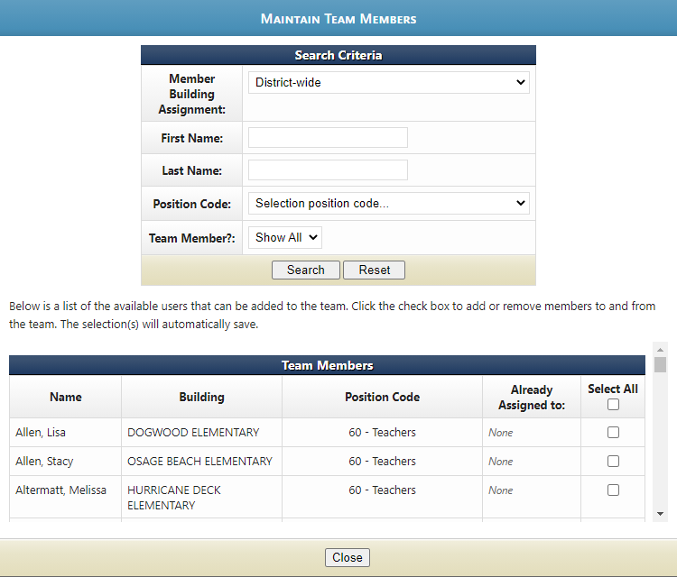

This window allows district administration to choose team members by choosing “Select All” or by choosing individuals or buildings. As each team member is checked, the “Already Assigned to:” column will change from “None” to the team assigned.
When the selection has been completed, click the Close button.
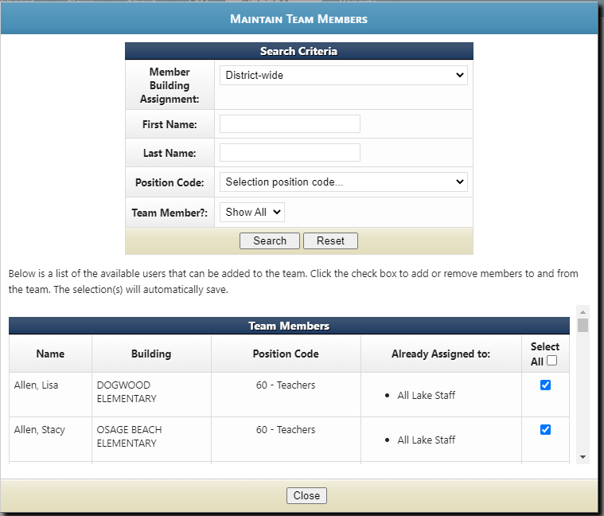
When the selection has been completed, click the Close button.
After this window closes, the list of Team Members for this team, as well as other teams they have been assigned, will be displayed.
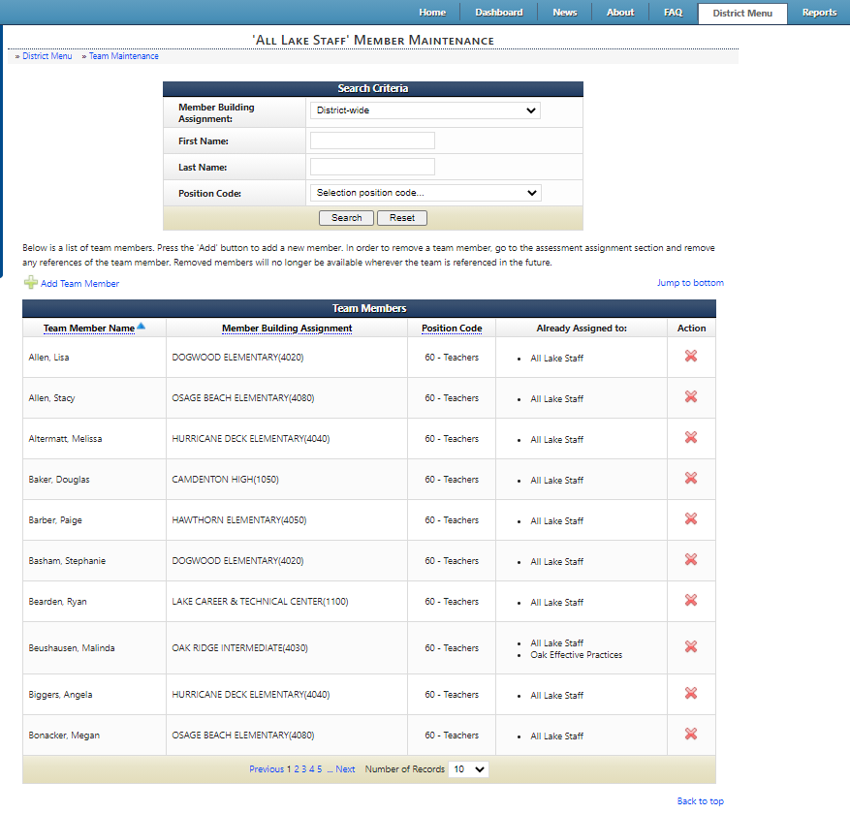
To delete a user, press the red X that corresponds to the person you want to delete.
This message will be displayed:
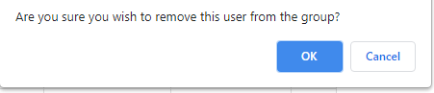
Press OK and that Team Member will be deleted.

